17.55: The mass of water that the camel saves is

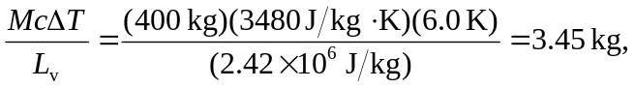
which is a volume of 3.45 L.

